Prototyping Update: My CEO in the Cave is still a work in progress. Toke Moeller, Wendy Morris, Glenda Eoyang, Phil Cass are helping me develop the curriculum. We may join with The Institute for Mindful Leadership, non profit for a series of training for CEO’s.

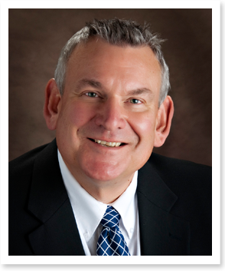
CEO In The Cave
Why CEO in The Cave?
Traditional Leadership skills do not work anymore.
“I work with companies that are in trouble – that’s what I do. In that role I see companies suffering. I see people suffering. The traditional ways of getting to solutions just don’t work. “Just fire him, go find another person.” CEO’s keep going back to what’s familiar and that isn’t getting the job done.
When we come in, we rarely need to go in and get rid of people. These companies have all the wisdom they need. It’s right there already in the room. How do you let that wisdom emerge? If companies knew how to do that, if they knew how to function as living systems, we wouldn’t need to be in there helping them.”
Bob Cass,
How do you find the way forward?
What if it requires you to be different?
What are the conditions for being a CEO is a different way?
Are you ready for a profound shift in how you see your world, your organization and who you are as a leader?
As we enter into the 21st Century, the issues facing leadership have become more complex and ambiguous. Leaders navigate a landscape that necessitate a different way to think, to act and to be.
The program will assist you answer those.

