Wisdom Dances
I am building a dancing community in Minnesota that is consciously using traditional dance for ecological, social and spiritual transformation.
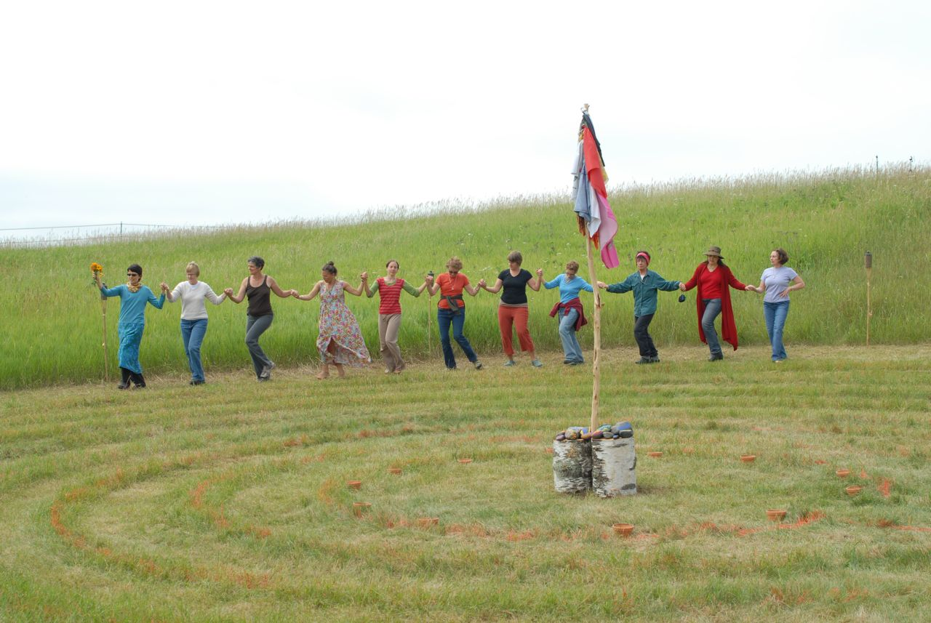
I am now planning a series of workshops throughout the 2012 growing season on the theme of cultivating community wellness and an abundant harvest. They will be along the themes of seeds, sprout, growing, harvesting, and storing.

Ways I hope to use the prototyping spirit in these workshops:
- Intentionally use different times and locations
- Reach out to different partners and allies
- Explore ways to “harvest” each gathering and learn going forward

How we can connect:
- Come! Sunday, April 1, 2012, from 1-3 PM at the Center for Performing Arts, 3754 Pleasant Ave, Minneapolis
- Give me feedback on this first prototype of publicity materials
- Do you know a garden or farm that would welcome dance? How about an indoor space?
- Can you connect me with musicians versed in Balkan, Greek or Near Eastern styles?

Wisdom Dances: Moving Communities Forward with Grace
Emily Jarrett Hughes * 612.729.4857 * www.wisdomdances.com
Like Wisdom Dances on Facebook or sign up for email updates.

